Colonial heritage : History Of Decentralization In Pakistan
While providing a detailed history of local governments is beyond the scope of this paper, it is instructive to mention aspects of this history that shed light in understanding the current decentralization. After briefly examining the pre and post independence period, we looking at the two most significant decentralization reforms prior to the current one, both interestingly also at the behest of nonrepresentativemilitary regimes under Generals Zia-ul-Haq and Ayub Khan respectively.
The Pre-Independence Period:
Local Governments under the British: The British introduced local governments in India1 not by building on the traditional structures of localgovernance, such as the village panchayats, but instead from scratch, following the annexation of Sindh in 1843 and of Punjab in 1849 (Nath 1929, Tinker 1968,Venkatarangaiya and Pattabhiram 1969). The main objective of the system was to co opt the native elite by establishing representative local governments. However, local governments were never substantively empowered as they were formed in a “top-down” manner in urban and rural areas, with extremely circumscribed functions and members who were not locally elected but nominated by the British bureaucracy (Tinker 1968). Instead, the Deputy Commissioner (DC), a district2 level agent of the non-representative central bureaucracy, emerged as principle actor at the local level (Ahmed 1964).
Democratic Processes at the Provincial Level:
Given the structure of the nonrepresentative state it is not surprising that the initial focus of political demands made by nationalist parties was for greater representation in provincial and central governments where substantive power lay. This shifted focus away from local governments and the strength of the nationalist movement in the early 20th century prompted the British government to make political concessions to Indian political parties by granting more autonomy at the provincial level.3 These changes are important in understanding the evolution of local governments since they sharpened the contrast between these nascent representative governments at the centre/province and the existing local governments, as the latter became less relevant as means of representation; the public debate having shifted to the more regional and central arena of the nationalist movement. This shift in political emphasis was a major factor behind the dormancy of local governments in the areas that were to constitute Pakistan (Rizvi 1976).
Patronage and Rural Biases under the British:
Another important feature of the British system of administration and local government was the creation of a rural-urban divide. Urban local councils were established by the British to provide
essential municipal services in urban areas. In contrast, rural councils were explicitly used to co-opt the local elite by giving them limited representation and as a result their capacity to provide essential municipal services became even more circumscribed than the capacity found in urban areas (Siddiqui 1992). The British centre used the deconcentrated agents of the central district
bureaucracy to co-opt and entrench local elites through a selective but extensive system of patronage (van den Dungen 1972). This was particularly true of the Punjab where the colonial bureaucracy had ample opportunities for providing patronage through land settlement policy, grant of colony lands in the canal colony districts of Punjab and the use of protective legislation like the Punja Land Alienation Act 1900 and the Punjab Pre-Emption Act, 1913 which prohibited transfer of land from agricultural to non-agricultural classes (Ali 1988, Pasha 1998, Metcalfe 1962). The Punjab tradition of establishing patron-client relationships between the central bureaucracy and the local elite resulted in a rural-urban division, which restricted politics away from the urban middle classes. Safeguarding the loyal landowning classes from economic and political domination by the urban elites became colonial policy (Talbot 1996). The dominance of the Unionist Party (representing large landowners of all religions) in Punjab’s politics during the early decades of this century was a direct manifestation of this phenomenon.
Thus what emerges from this brief history of colonial local governments is that the system was not introduced in response to popular demand or local pressure, but primarily as a result of the central government’s initiative and functioned under the imperial bureaucracy’s control. Moreover, from the beginning, there was a contradiction between the development of autonomous local self-governing institutions and imperialist local level bureaucratic control
with the imperative of creating a loyal native class, and it is the latter that dominated. The rise of the nationalist movement, during the early twentieth century, demanded more political space at the central and provincial level. As a result these higher tiers emerged as the hub of political activity, which not only shifted political focus away from local governments, but also resulted in a lack of political ownership to build local governments by nationalist politicians. However, even the provincial autonomy that was granted was heavily circumscribed and extensively loaded in favor of the non-representative bureaucracy at the imperial centre.
LORD RIPPON 1882
In 1880 A.D. election took place in England in which Liberal party came to power and its Leader Gladstone became the Prime Minister of England. When Gladstone came to power, Viceroy Lord Lytton, resigned. Gladstone sent Lord Ripon as viceroy of India in 1880. Ripon was industrious, able with a deep moral earnestness. He may be described as Gladstone’s agent in India. Ripon was liberal in his attitude and made some remarkable changes in the administrative system of India.
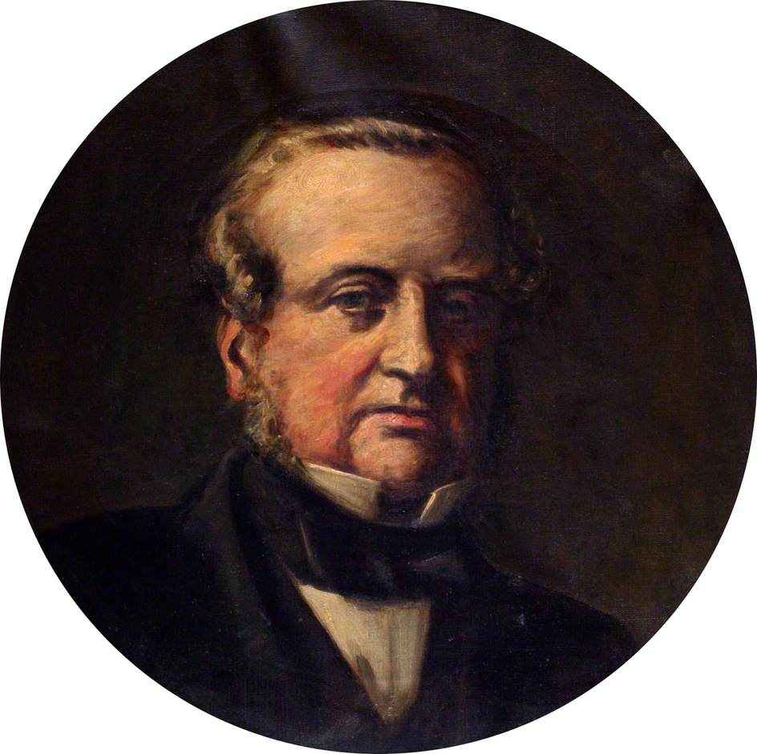
He granted various facilities to the Indians. P.E. Roberts writes about Lord Ripon, “He was a true liberal of Gladstonian Era with a strong belief in the virtues of peace, laissez faire, and self government.” Ripon was a true Democrat. He took some steps towards liberalizing the administration in India. His aim was to give popular and political education to the Indians. He formulated the local self government and laid the foundations of representative institutions in India.

Reforms:
Repeal of Vernacular Press Act, 1882:
Lord Ripon repealed the Vernacular Press Act of 1878 passed by Lord Lytton by Act III of 1882 and thus news papers published in vernacular languages were allowed equal freedom with the rest of the Indian Press. This action of Ripon went a long way in conciliating public opinion.
The First Factory Act, 1881:
To improve the lot of the factory workers in towns, he passed the first Factory Act in 1881. The Act prohibited the employment of children under the age of seven, limited the number of working hours for children below the age of twelve and required that dangerous machinery should be fenced properly.
The Act also made provision for one hour rest during the working period and four days leave in a month for the workers. Inspectors were appointed to supervise the implementation of these measures. Thus for the first time the British Government tried to improve the working conditions of labourers in factories.
Economic Reforms: Financial Decentralization, 1882:
Lord Ripon like his predecesser, Lord Mayo was the follower of the policy of financial decentralization. Ripon divided the sources of revenue into three categories, Viz. Imperial, Provincial and Divided.
1. Imperial Heads:
Revenue from Customs, Posts and Telegraphs, Railways, Opium, Salt, Mint, Military Receipts, Land Revenue etc. were included in the imperial head. The Central Government was required to meet the expenses of central administration out of this revenue.
2. Provincial Heads:
Revenue from Jails, Medical slices, Printing, Roads, General Administration, etc. were included in the provincial heads. As the income from provincial heads was insufficient for provincial expenses, a part of Land revenue was assigned to the provinces.
3. Divided Heads:
The revenue from Excise, Stamps, Forests, Registration etc. was divided in equal proportion among the Central and Provincial Governments. The system of Divided Heads started by Ripon remained operative till it was modified by the Reforms of 1919.
Local Self Government:
Lord Ripon is still remembered by the Indians for his attempts to establish local self government. Lord Ripon believed that the aim of Local Self Government was to train the Indians to manage their own affairs themselves.
Lord Ripon wrote, “What I want is a gradual training of the best, most intelligent and influential men in the community, to take an interest and active part in the management of their local affairs.” Ripon made it clear that he was advocating for the decentralization of administration not with a view of improving administration but as an instrument of political and popular education.
The idea of local self government was not a new one. Municipalities had already existed in big towns but the Government nominated the municipal commissioner. In rural areas there were committees to, manage local affairs such as sanitation, the repair and construction of roads, maintenance of ferries, education etc.
However the local committees were all under official control. Moreover the area served by their committees was too large. So that their members were not sufficiently acquitted with the needs of the people of different localities. Lord Ripon sought to remove these obstacles in the sphere of Local Self government by his resolution of 1882.
Accordingly, in rural areas District Boards and Local Boards known as “tahsil or “taluk boards were established. The members were to be elected by rent-payers rather than nominated by the Government. In towns the powers and responsibilities of the Municipalities were enlarged. The members were to be partly elected and partly nominated.
The chairman was to be a non-official member. The nominated members should not be more than one third of the total strength. The management of health, education, roads and communications were to remain under the control of the local boards. The local bodies were given certain financial powers but the Government retained the powers of inspection.
The local bodies were kept free from government control. But if the Boards were not discharging their duties properly, then the Government had the right to dissolve them. But usually, the government did not interfere in the affairs of the local bodies. The Local Self Government Acts were passed in different provinces during 1883-85. The work of lighting, cleaning of streets, sanitation, education, water supply, medical aid etc. was assigned to the local bodies of Madras, Punjab and Bengal.
Educational Reforms:
Lord Ripon appointed an Education Commission in 1882 under the chairmanship of Sir William Hunter to review the progress of education in India, since Wood’s dispatch of 1854. The commission laid emphasis on the special responsibility of the state for the improvement and expansion of primary education.
It recommended that the management of elementary schools was to be entrusted to the newly established local and municipal boards under the supervision and control of the Government.
The Commission was satisfied with the system of Grants-in-aid, urged its extension for secondary and higher education and also recommended that the Government should withdraw as early as possible from the direct management of secondary schools. It also made suggestion for the improvement in commercial and vocational education. The commission also made suggestions for the spread of female education. Lord Ripon accepted most of the recommendations of the commission.
Other Reforms:
During that time the recruitment to Indian Civil Service examination was held in England only and the age limit was 18. Ripon urged for the simultaneous examination both in India and in England He failed in his objective because he could not motivate the Government. However he succeeded in enhancing the age limit from 18 to 21.
The Ilbert Bill Controversy, 1883-84:
Lord Ripon was a Liberal and he did not believe in castecism. So he sought to abolish “Judicial disqualifications based on race distinction.” According to the criminal procedure code of 1873 no magistrate or sessions judge except in presidency towns could try an European British subject unless he himself was of European birth.
Hence Lord Ripon sought the help of Sir C.P. Ilbert, the law member of the viceroy’s council to abolish the “judicial disqualification based on race distinction”. Sir Ilbert introduced a bill popularly known as the Ilbert Bill on 2nd February 1883 and through this bill the British European subjects were brought under the jurisdiction of Indian magistrates and judges.
But the bill was vehemently opposed by the European Community in India who formed a Defence Association to defence their special privileges. They passed resolutions urging the British Government to recall him before the expiration of the period of his office. After a prolonged tug of war Ripon bowed before the storm of agitation and modified the bill.
The amended bill provided that every European subject brought before a District Magistrate or Session Judge whether an Indian or European could claim to be tried by a Jury of twelve, at least seven of whom were to be Europeans or Americans. Though the Ilbert Bill controversy widened the racial feeling between the Indian and the Europeans yet it helped the Indians to learn the lesson that a powerful Government could be deviated from its purpose by organized agitation. It also intensified the feeling of unity among the Indian people.
Ripon resigned from his post in 1884 before the term of his viceroyalty was over. He was very popular with the Indians. According to Pandit Madan Mohan Malviya, “Ripon was the greatest and the most beloved Viceroy whom India has known.” Ripon is remembered according to Surendra Nath Banarjee for, “the Purity of his intentions, the loftiness of his ideas, righteousness of his policy and his hatred of Racial disqualifications.”
At the time of his departure for England the priests blessed him and offered him gifts. He was the only person who realized that the people of India should themselves make effort to attain freedom. Report’s doings in India marked the beginning of the political’ life in India. His departure was followed by the establishment of Indian National Congress in 1885.

